**SQL FUNDAMENTALS**

## WHERE & LIMIT Clauses

**Introduction**

In this lesson, you will focus on the WHERE clause in SQL. The WHERE clause is used to filter records.

* It allows you to define a specific search condition for the result set returned by a query.
* So, the result set only consists of the records that fulfill the predefined condition(s).

The WHERE clause is mostly used with the SELECT statement. In addition to the SELECT statement, it may also be used with some other statements like DELETE and UPDATE. It's used in a query after the FROM clause as in the below example.



1

2

SELECT column_name(s) FROM table_name WHERE condition(s);

By using this query, you explain to SQL that you only want to get the data that pass the defined condition(s) as a result set.

### WHERE Clause - Operators

You can use the following operators in the WHERE clause. 

| **Operators in the WHERE Clause** | |
| --- | --- |
| **Operator** | **Description** |
| = | Equal to |
| > | Greater than |
| < | Less than |
| >= | Greater than or equal |
| <= | Less than or equal |
| <> | Not equal. This operator may be written as != in some versions of SQL |
| BETWEEN | Test if a value is between a certain range of values |
| LIKE | Determine if a character string matches a predefined pattern |
| IN | Test whether or a value matches any value in a list |

**student_table**

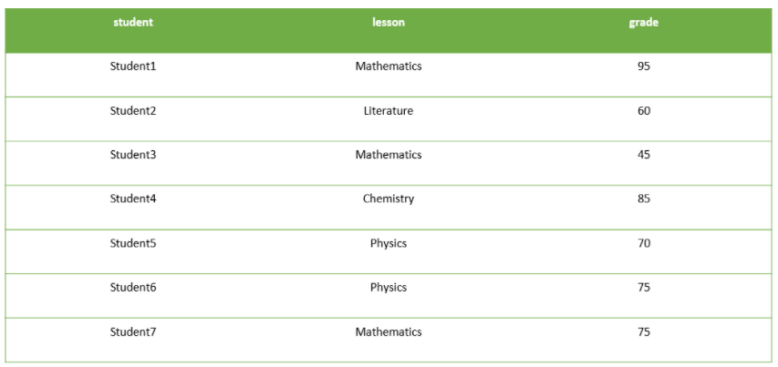

Assume that;

You have a table named student_table as above.

If we want to select only the records of which grade is higher than 70 in the result set, then we should write a query like this.  
  
query :

SELECT * FROM student_table WHERE grade > 70

After the execution of the query, you will get a result set like below.  
output:

student lesson grade

---------- ----------- ----------

Student1 Mathematics 95

Student4 Chemistry 85

Student6 Physics 75

Student7 Mathematics 75

**Example-1**

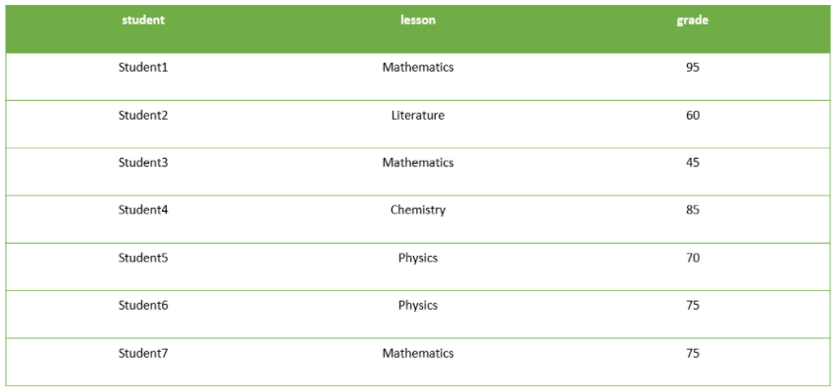

* You want to see only the records of which lesson is Mathematics in the result set.
* Then, you should write a query like this.

query :

SELECT * FROM student_table WHERE lesson = "Mathematics";

After the execution of the query, you will get a result set like below.

output :

student lesson grade

---------- ----------- ----------

Student1 Mathematics 95

Student3 Mathematics 45

Student7 Mathematics 75

### Example-2

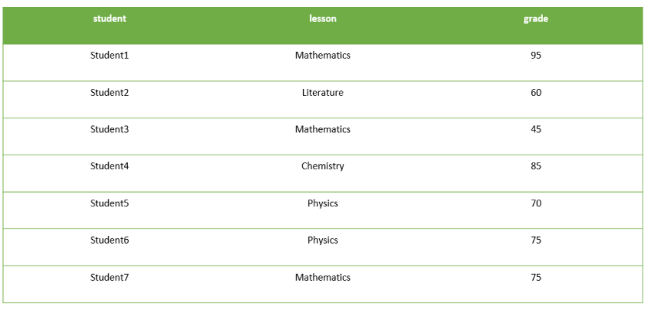

Let's write a different query to select only the records of which grade is lower than 70 in the result set. Our  query will be as below:  
query :

SELECT * FROM student_table WHERE grade < 70

After the execution of the query, you will get a result set like below.  
output:

student lesson grade

---------- ---------- ----------

Student2 Literature 65

Student3 Mathematic 45

### LIMIT Clause

In this lesson, you will focus on the LIMIT clause in SQL. The LIMIT clause is used to filter records. It constrains the number of rows returned by a query. Assume that your query returns one thousand rows. But you only want to see the first 10 rows in the result set. In such cases, we use LIMIT clause to obtain the desired output.   
  
Here is the syntax of the LIMIT clause.

SELECT column_name(s) FROM table_name LIMIT number_rows;

Let's select all the columns of the student_table and return the first 3 rows.  
  
query:

SELECT * FROM student_table LIMIT 3;

output:

student lesson grade

---------- ----------- ----------

Student1 Mathematics 95

Student2 Literature 65

Student3 Mathematics 45

We can also combine LIMIT with WHERE. LIMIT clause is placed after the WHERE clause. Let's select the students whose grade is higher than 70 and let our query return the first 2 rows.  
  
query:

SELECT * FROM student_table WHERE grade > 70 LIMIT 2;

output:

student lesson grade

---------- ----------- ----------

Student1 Mathematics 95

Student4 Chemistry 85